Git and Git Hub

1.Install git
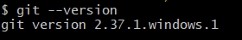
2.Create a repo in github with read me.md and ignore.file
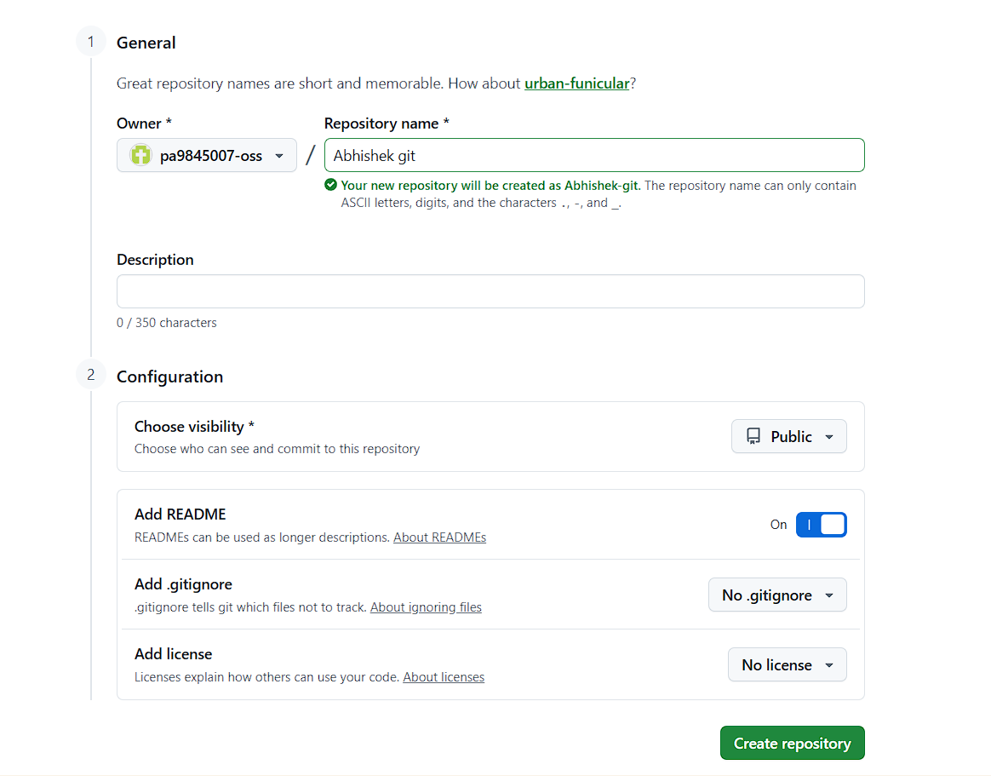
3.Clone the created repo to local.
# Git clone [repository link]
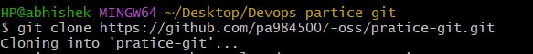

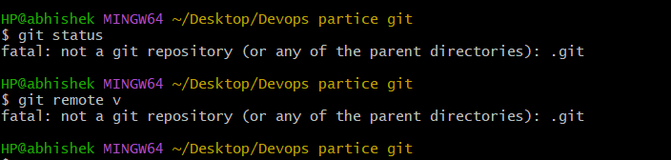

4.Create two files in local repo.
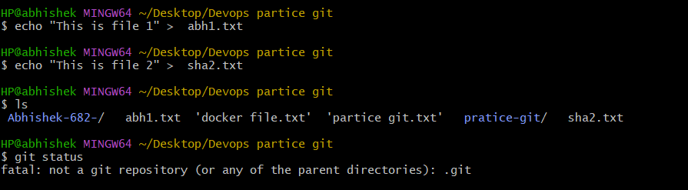

5.Commit two files and push to central Repository.
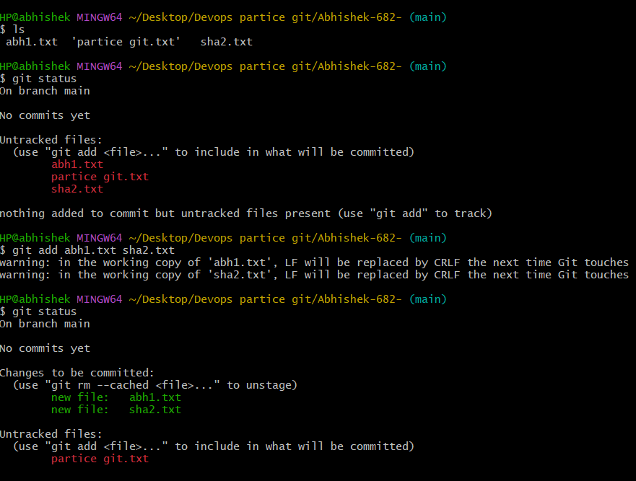
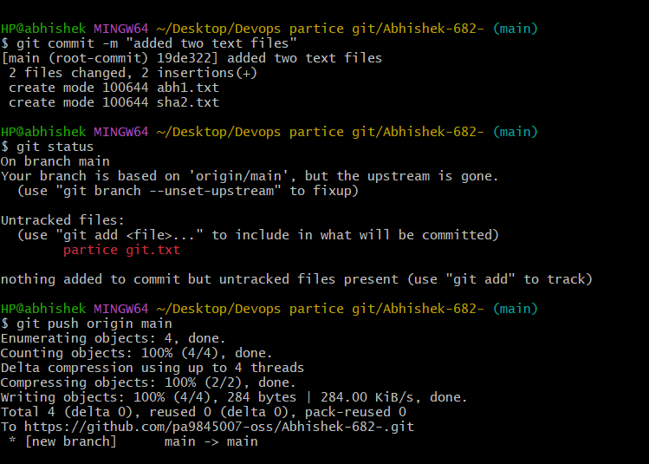

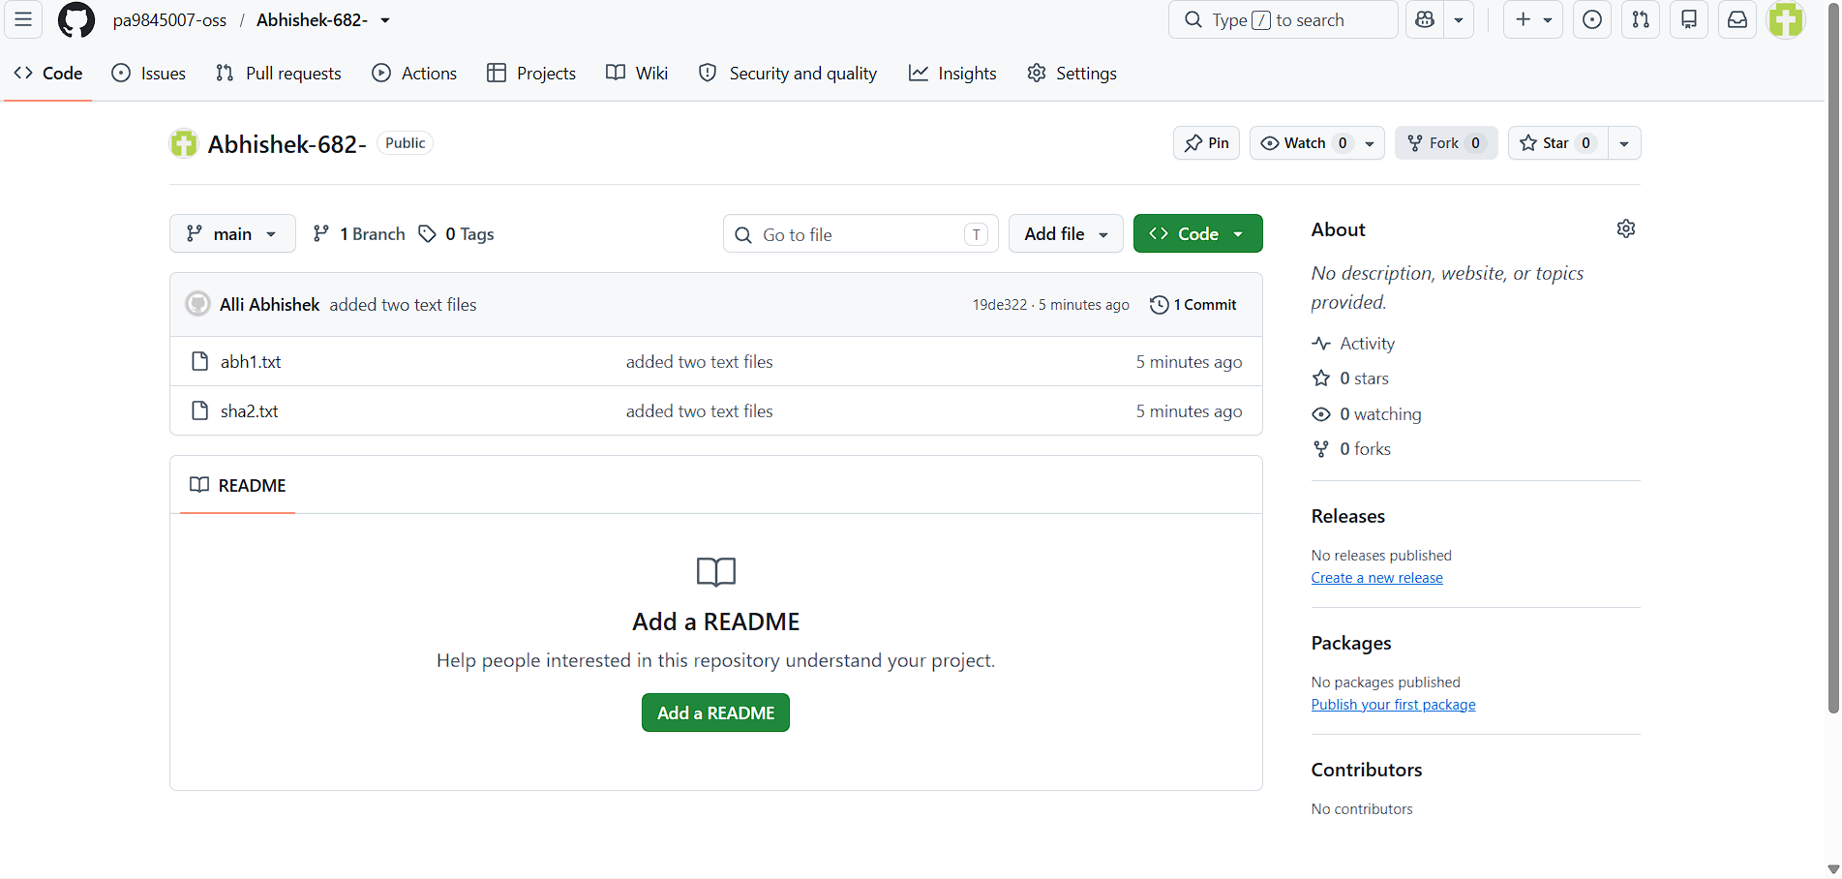
6.Create a branch in local and create a sample file and push to central.
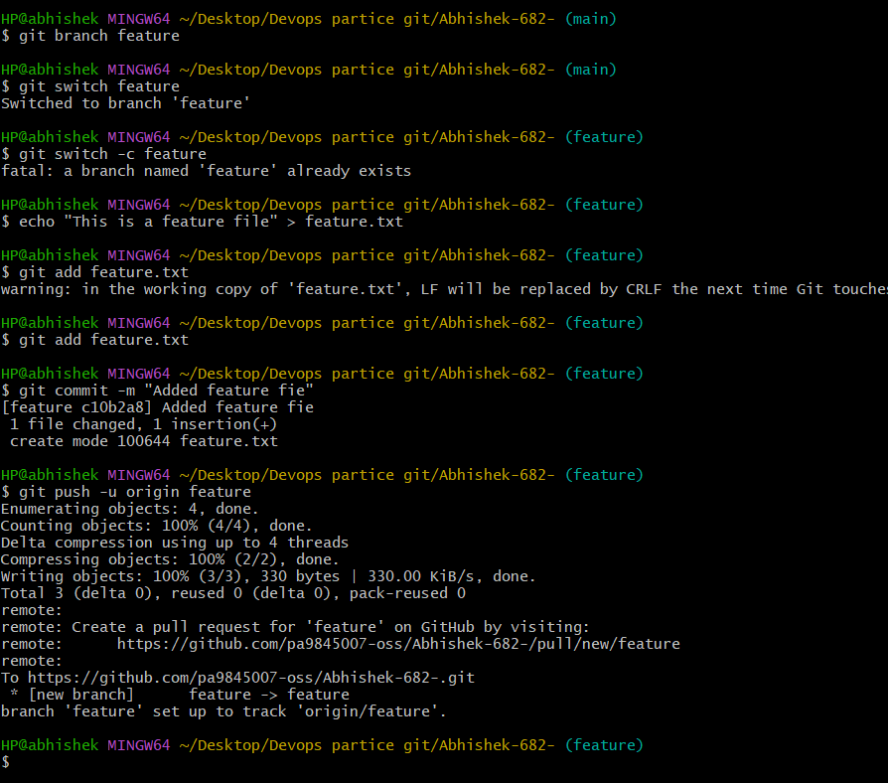

7. Create a branch in github and clone that to local.
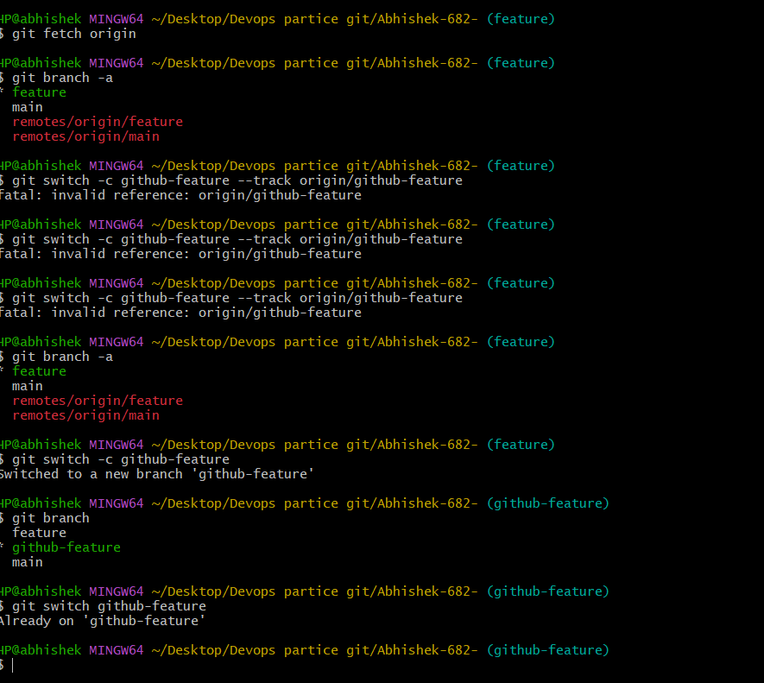

8.Merge the created branch with master in git local.
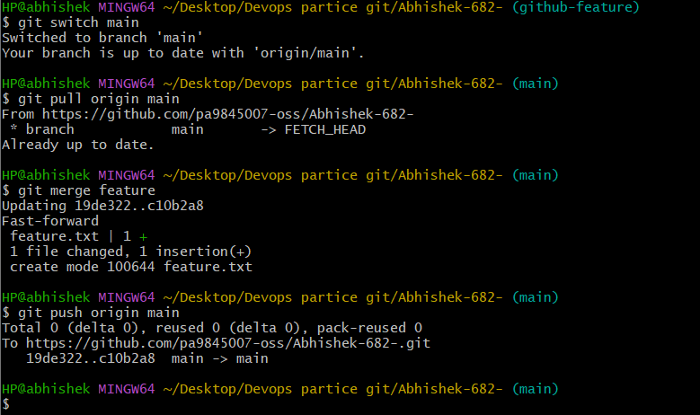

9. Merge the created branch with master in github by sending a pull request.
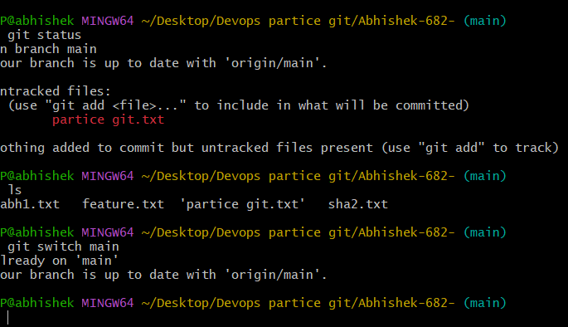

10. Create a file in local and send that to branch in github.
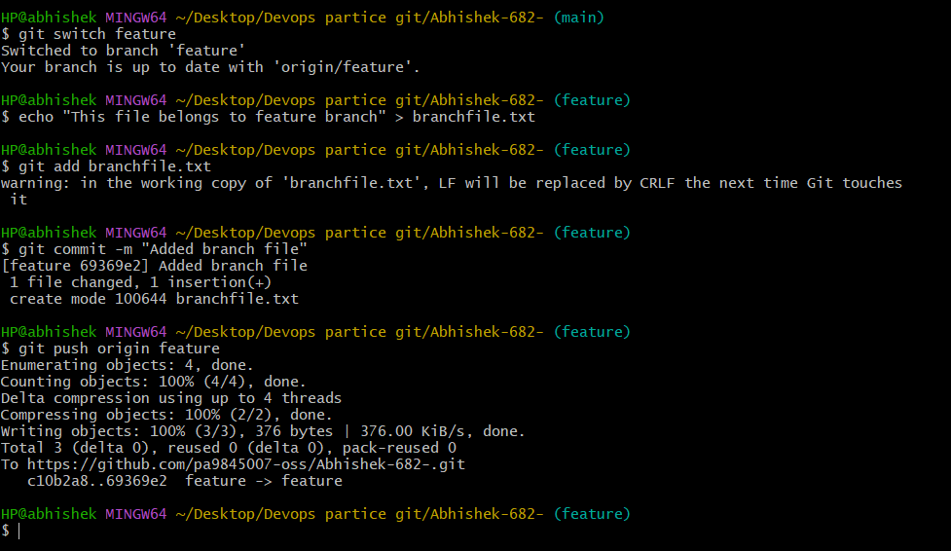

11. Clone only a branch from github to local.
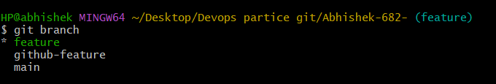
12. Create a file with all passwords and make that untrackable with git.
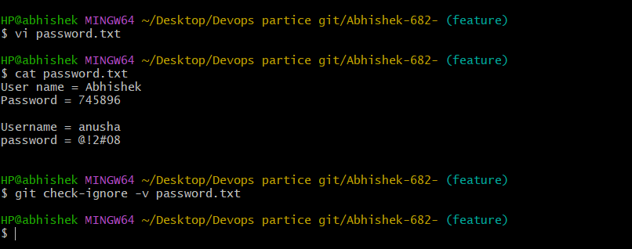
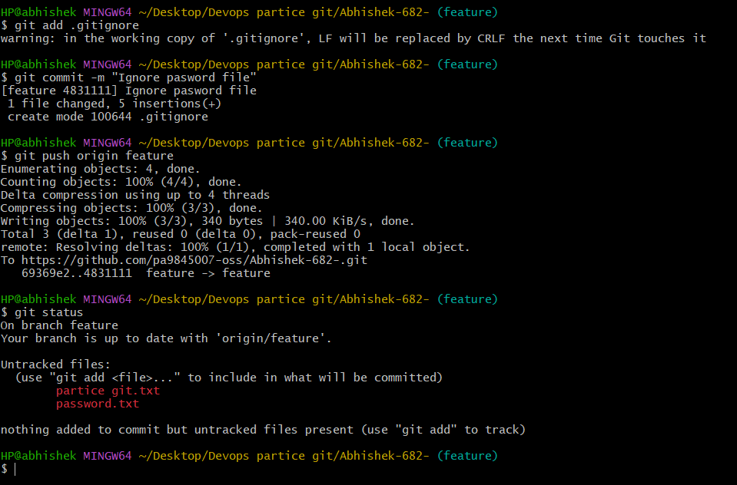
13. Make a commit and make that commit reset without savings changes.
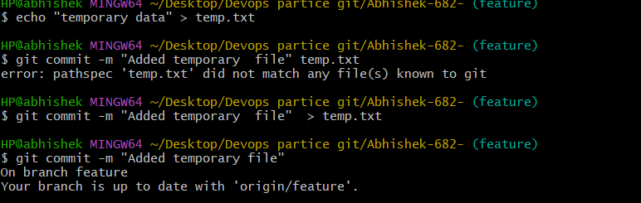
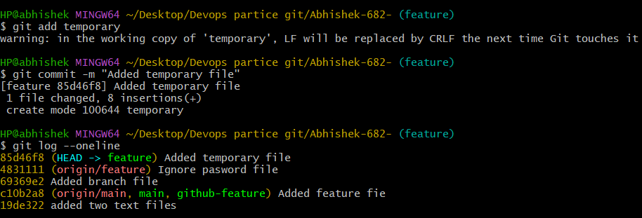
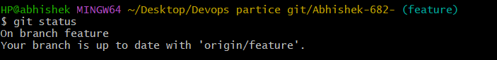
14. Revert a commited commit to the older version.
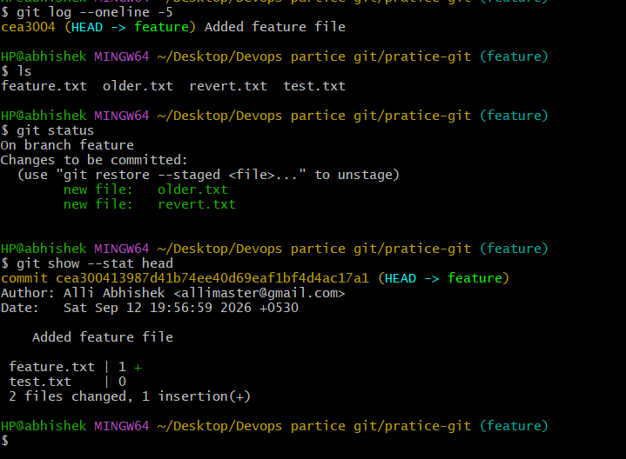
15. Push a file to stash without savings the changes and work on another file.
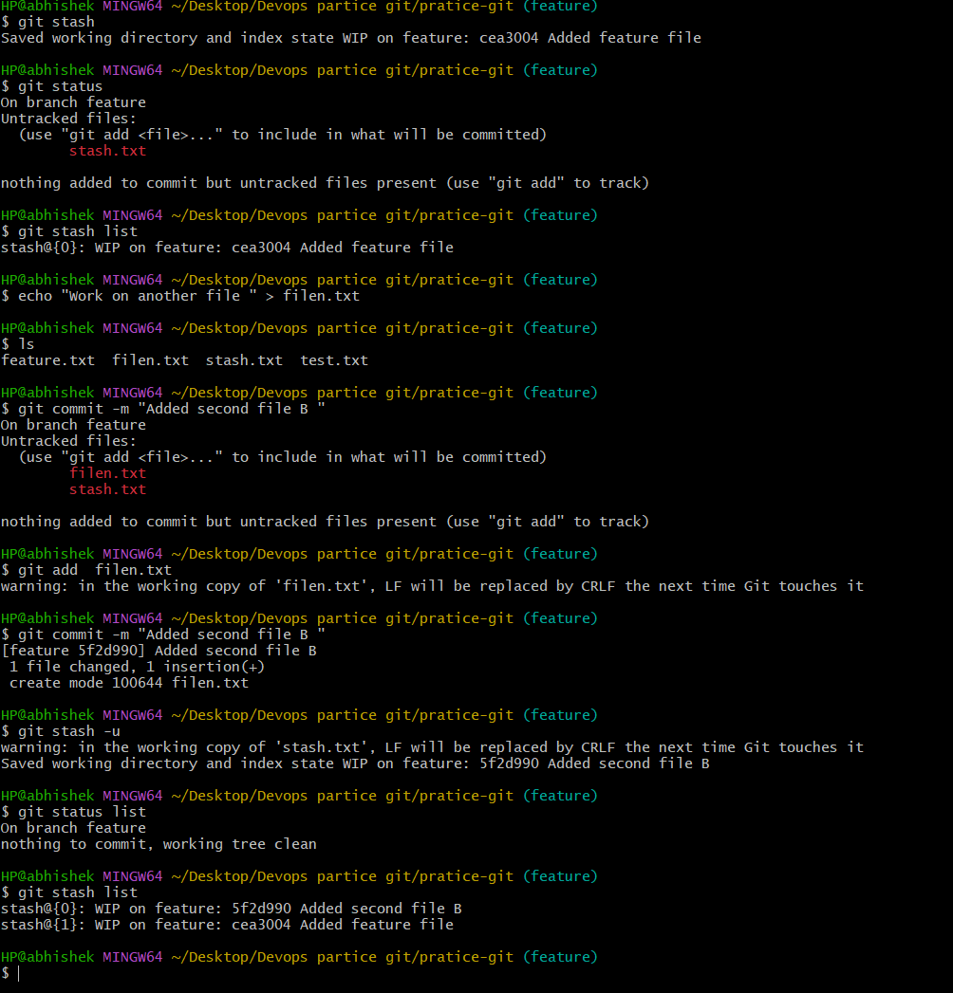

16. Undo the stash file and start working on that again.
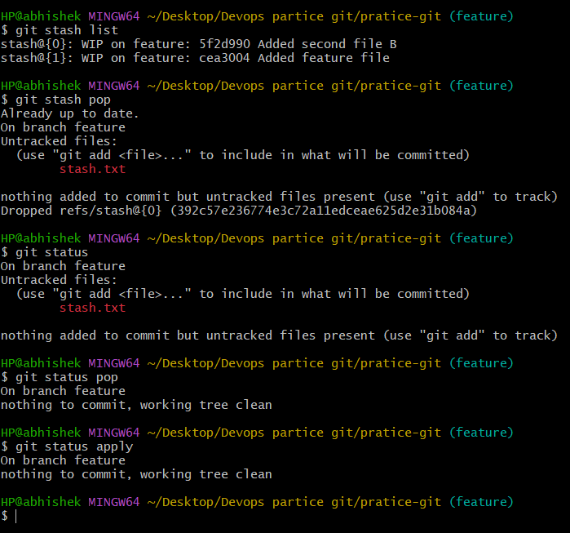

17.Generate a ssh-keygen and configure into github.
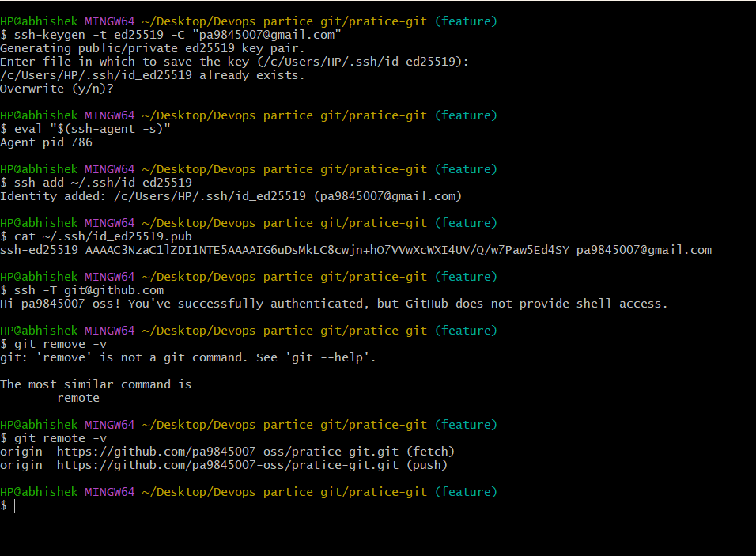
18. Configure webhooks to github.
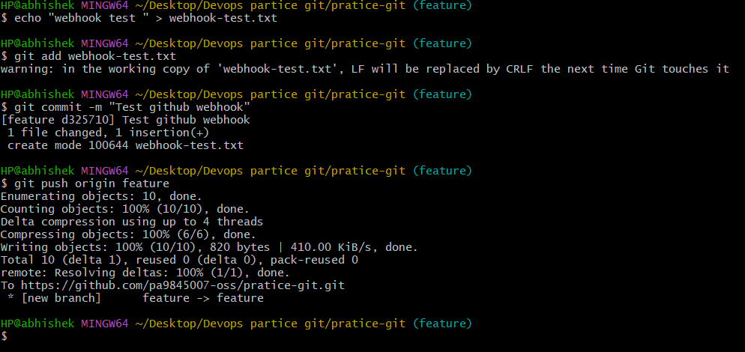

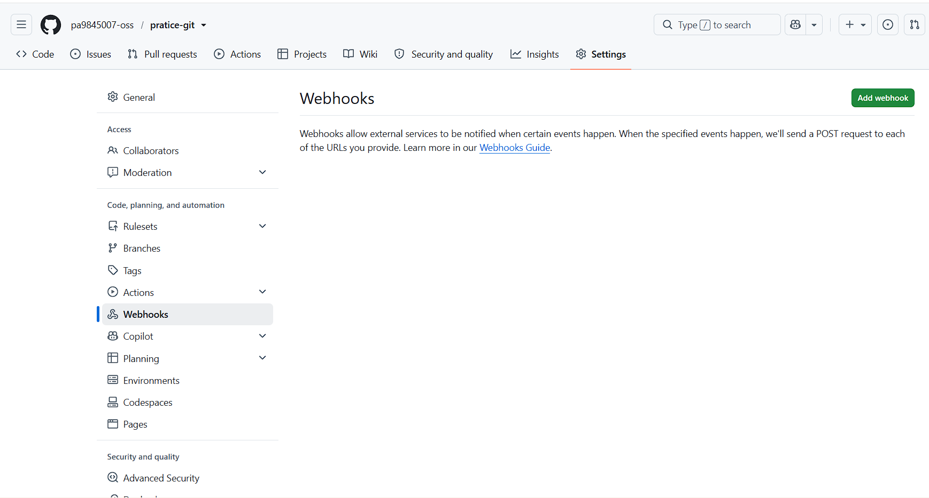
19. Basic understanding of .git file.
What is .git ?
It is a hidden directory created by git init. It stores the complete metadata and history of a Git repository, such as commits, branches, configuration, and the staging/index information.

20.Check all the logs of git.
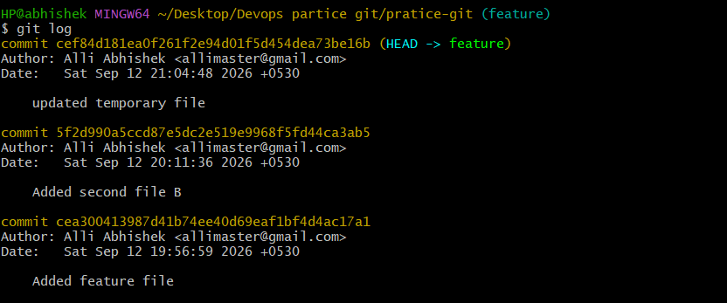
21.Rename the commit message.
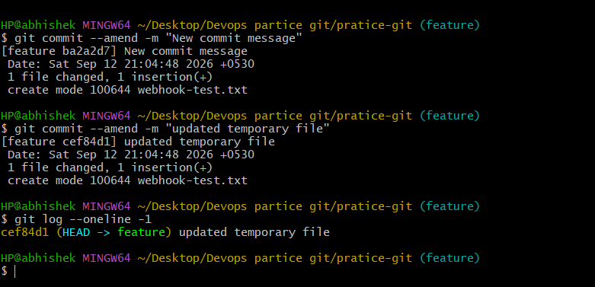
22.Merge multiple commits into single commit.

